- News
- Sports
- Opinion
- Obituaries
- Politics
- Arts & Life
- More...

Opinion: The girls of SOLA
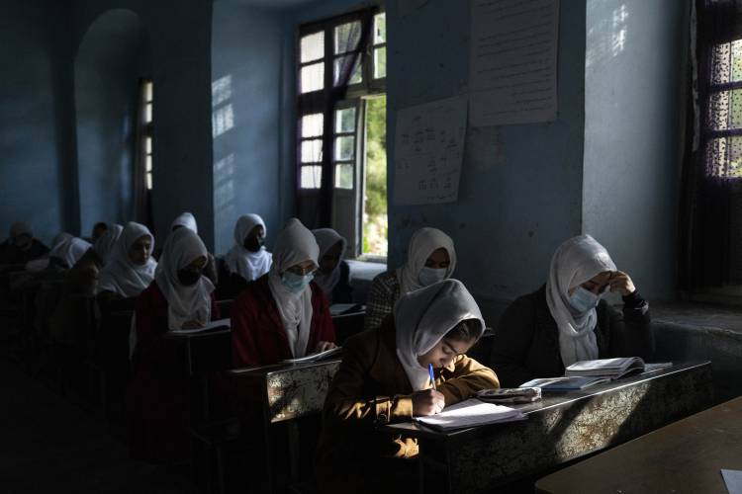
Afghan girls participate in a lesson at Tajrobawai Girls High School in Herat, Afghanistan on Nov. 25, 2021. Petros Giannakouris/ AP

By STEPHANIE RUTT
Published: 3/12/2023 8:00:35 AM
Modified: 3/12/2023 8:00:14 AM
Rev. Dr. Stephanie Rutt is founding minister of the Tree of Life Interfaith Temple in Amherst. She lives in Nashua. To read more of her writing visit becomeaforceforgood.com.
It was something about those smiles, all bright and shiny on the young faces of the girls of SOLA, aired on 60 Minutes on February 26th. SOLA is the Afghan word for peace and also stands for School of Leadership Afghanistan. Its founder, Shabana Basij-Rasikh, was featured on the program and she impressed me as a kind of girls’ warrior, the embodiment of stealth courage, infused with a clear sense of purpose, the kind that rises to the surface when one is unwavering, fully committed, to a cause. Her cause? Educating Afghan girls to become leaders in their chosen fields.
Today the school is thriving in Rwanda, following a harrowing escape from Afghanistan in August of 2021 when U.S. troops were abruptly withdrawn and the country fell into chaos.

As the young girls were interviewed, they shared their dreams for the future. What did they want to be? A surgeon, architect, politician, and spy (made me chuckle) to name a few. I was struck by their faces all lit up with the innocence of, “The world is my oyster. Anything is possible!” But, in the next moment, my heart sank when I was reminded of the status of all the girls and women still left behind living under Taliban rule. No education beyond the 6th grade. No venturing outside alone. Must always be fully covered.
Silenced. Hidden. Invisible.
It’s interesting to me that we can spend billions of dollars to support the freedom and sovereignty of Ukraine (which I fully endorse) but leave behind, turn away from, half a nation’s population to live in tyranny, imprisoned in plain sight. Are they not as worthy of a commitment from the free world as the people of Ukraine? Who fights for them in equal measure?
I suspect many contemplating this life under Taliban rule might try to quickly dismiss any rising discomfort with such well-accepted notions as we shouldn’t be interfering with the religious norms and practices of other countries. I confess I too, at times, have felt the same. Until I saw those faces, the shining ones. And, by contrast, the covered ones I couldn’t see but so wanted to.
As an interfaith minister, my life’s work has been about finding unity in diversity. I’ve often said it’s fundamental that we strive to at least respect religious differences even when we personally disagree. But to enslave girls and women, making them prisoners in their own homes, and to deny them to be seen or heard in any regard outside of their cells, well, is simply not okay and must not be tolerated by the free world. And such enslavement cannot be allowed to thrive behind a fictitiously created shield of professed religious legitimacy. In my view, this is not so much about the religion of Islam, which has brought us many beautiful sacred teachings and practices, as it is about the sanctioning of pervasive gender-based exploitation. It’s an egregious abuse of power. Pure and simple.
And as I looked at the images of the women of Afghanistan completely covered, I could only wonder what is being lost to us. The Native American Ute have a saying, “God gives each of us a song.” I think of our unique song as that which naturally draws us toward what we love. It can be a vocation or avocation. Doesn’t matter. What matters is that when are moved to do what we love, we naturally come alive and our soul’s song goes out to serve all around us in ways we may rarely recognize.
What songs are being lost to us hidden just behind the veil of the Burqa? What dreams lie dormant waiting for fresh air, fertile ground, and the light of day? Recalling the dreams of the girls of SOLA, what new medical advances may be germinating? What engineering wonders wait to grace the sky? What speeches remain unspoken, ones that could move and inspire many for generations? And, what skills, creations, inventions, works born of struggle, sweat and wonder, wait just beyond the veil? We cannot know.
Imagine with me for a moment a young girl or woman you love, how it might feel to see her locked away hidden from sight, her voice hushed and monitored. To imagine just how hard she tries to stand again each day struggling under the weight of oppressive helplessness; yet we pray, hope beyond hope that, still, she clings fast to her dreams, the ones that can’t fail to make her shine, if only in the dark, secret shadows, of night.
Perhaps, if we could imagine, it would spur each of us to become a girls’ warrior so, never again, could a shining face be dulled and hidden, a dream banished, and no song could forever remain unsung.

